step 1 : open terminal

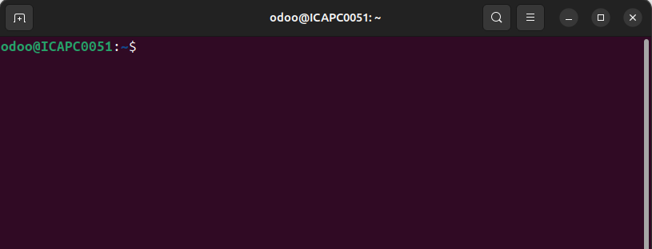
-- show like that

step 2 : install python version

you can install any python version here I will installing latest python virsion

code : sudo apt install python3.12-venv

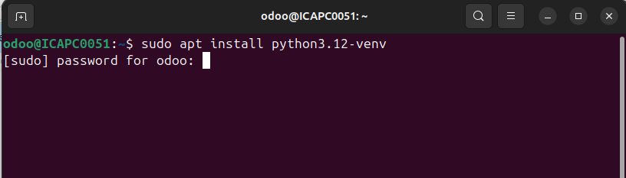
- after enter password you can see like that ,
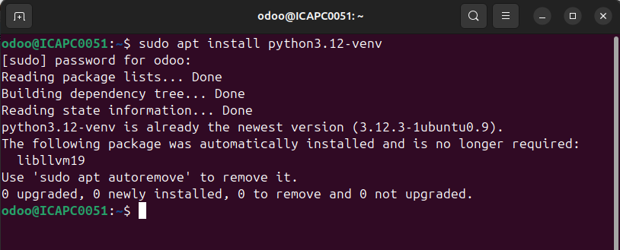
now,python3.12 version successfully created
step 3 : create virtual environment

code : python3 -m venv [virtual_environment_name]

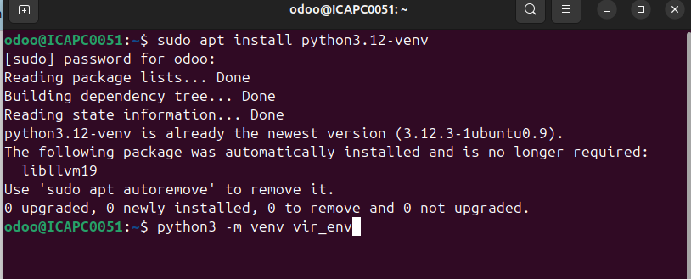
here, I have give a name as vir_env.
you can give any name

step 4 : active the virtual environment

Before installing any packages, you must activate the environment.
code : source [virtual_environment_name]/bin/activate

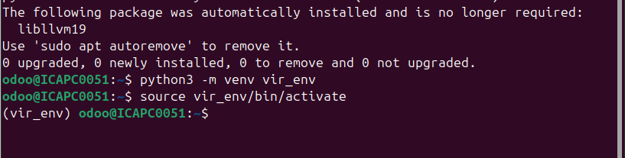
after activate, you can see like that and your virtual environment are activate

step 5 : install python libraries

Now you can able to install python libraries using this code : pip install [library_name]
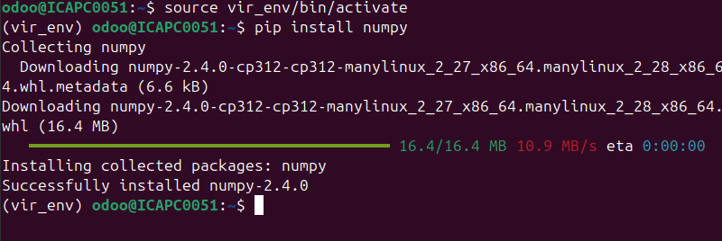
if you want to show all libraries use code : pip list

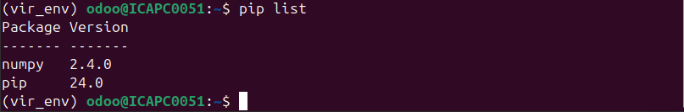
here, display all the libraries which you are installed

step 6 : Deactivate

code : deactivate

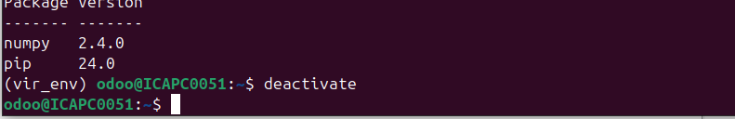
now you deactivate your virtual environment

